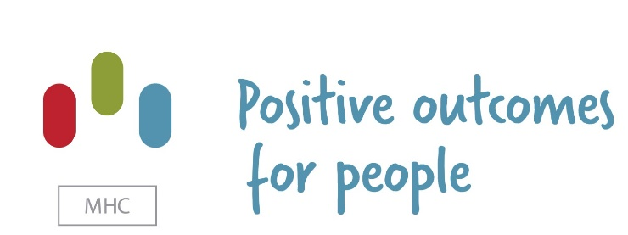

job description SUPPORT WORKER – MEOLS DRIVE

Purpose of the role:

Under supervision of the Nurse in Charge / Team Leader/ Management Team, and by working collaboratively as part of a team, the job holder will play an important part in the delivery of care to service users. You will be involved in supporting the needs using the person centred approach and positive behaviour support plan so as to enhance the opportunity’s for the individuals to live as independent as possible and to achieve the best quality of life.

Client Group Description:
Meols Drive provides residential with nursing support to men (aged 18years+) living with a borderline to moderate learning disability and/ or additional complex needs including Autism, epilepsy, behaviour that challenge and Mental Health conditions.

Meols Drive forms part of the MHC Health service portfolio which sits within the MHC UK Ltd group.

Duties and Responsibilities

- To carry out all Company duties, tasks and responsibilities in accordance with the Company's principles of care, whilst ensuring the safety, care and well-being of service users and colleagues at all times.

- To handle service users' finances where appropriate and record all transactions as outlined within Company guidelines.

- To encourage the service user to develop and maintain skills in all reasonable and practical situations, through occupational therapy or work placement.

- To assist service users with personal care as outlined in individual care specifications with due regard to the dignity and privacy of the person ensuring that any continence issues are dealt with sensitively.

- Prepare food in accordance with the service user’s choice, dietary requirements, and preferred methods in a safe and hygienic manner.

- Assist the service user with eating and drinking as required.

- Administer such prescribed medication as is required in accordance with the Company's administration of medicines policy.

- Maintain confidentiality regarding all issues and information relating to service users within the bounds of the Company's policy on confidentiality and observe service users’ rights.

- To actively encourage service users to participate in any social, educational and leisure pursuits or general activities. To provide practical support to enable them to do so.

- Read and keep up to date with Company policy through Policy and Procedure and Human Resources manuals available within the homes and the Company guidance notes issued to all staff and updated on a regular basis.

- Following completion of Induction Training, embark upon QCF Level 2 in Health & Social Care and complete training within agreed timescale.

- Comply with the Company's, service users' or Social Services Department's reporting requirements with regard to monitoring the care of service users, statistical, financial or quality assurance information.

- To attend staff meetings and Company training.

- To provide a respectable role model for service users and respect the integrity of the Company at all times.

- If an approved driver, to drive Company vehicles with due care and attention taking into account the needs, safety and comfort of service users.

- To report any suspicions, concerns, or if witnessing any incidents affecting the safety or well-being of service users/patients to a senior colleague immediately.

AN ENHANCED DISCLOSURE FROM THE CRIMINAL RECORDS BUREAU IS REQUIRED FOR THIS ROLE.

ADDITIONAL INFORMATION

The following supplementary information will form part of your job description.

Codes of Professional Conduct:
Staff are required to abide by the all relevant Company policies and procedures and any relevant national / professional Codes of Conduct or Practice.

Confidentiality:
Information relating to patients, employees and business of the Company must be treated in the strictest confidence. Under no circumstances should such information be discussed with any unauthorised person(s) or organisations. All staff must operate within the requirements of the Whistleblowing Policy.

Health & Safety:
Employees are required to ensure they are aware of, and comply with, policies and procedures relating to Health & Safety (whether statutory or Company), and assist in ensuring the compliance of other staff.

Equality & Diversity:
The Company is committed to ensure that no job applicant or employee receives less favourable treatment on the grounds of age, disability, gender, race, religion or belief, sexual orientation, marital status, gender reassignment or pregnancy/maternity. We fully support the right of all staff to equal opportunities and are committed to the development of a diverse workforce.

Policies:
It is the responsibility of staff to be familiar with Company policies that affect them, and work within the scope set out in them. Managers are responsible for ensuring staff know of, and work within the Company’s policies, procedures and protocols.

NOTE: Notwithstanding the detail within the job description, the post holder will undertake such duties as may be determined by the Company from time to time, up to or at a level consistent with the principal responsibilities of the post.

person specification SUPPORT WORKER – meols drive

Education and Qualifications | Essential (E) / Desirable (D) | Method of Assessment
Health and Social Care NVQ/ QCF Level 2 | D | All By Application
Health and Social Care NVQ/ QCF Level 3 | D | All By Application
A commitment to achieve the required NVQ/ QCF level | D | All By Application
Relevant courses and qualifications | D | All By Application
Knowledge and Experience
Previous experience of working within a similar health care setting | D | All by Interview / Assessment
Experience working with people who have Learning Disabilities, Autism, epilepsy or Mental Health conditions and associated with behaviour that challenges | D | All by Interview / Assessment
Knowledge of a Learning Disability, Acquired Brain Injury, autism, epilepsy and personality disorder  Experience of preparing and organizing activities | D | All by Interview / Assessment
An awareness of the rights and needs of people within our services | D | All by Interview / Assessment
Skills & Abilities
Ability to work on own initiative and as part of a team | E | All by Interview / Assessment
Ability to work to agreed plans | E | All by Interview / Assessment
Excellent communications skills – to be able to liaise effectively with Service Users, Service User family members, Multi-Disciplinary Team and Office Staff. | E | All by Interview / Assessment
Ability to promote independence | D | All by Interview / Assessment
Basic administrative skills | D | All by Interview / Assessment
Personal Attributes
Ability to display empathy, warmth, patience and understanding. | E | All by Interview / Assessment
Enthusiastic and self-motivated. | E | All by Interview / Assessment
Ability to work flexibly, including evenings and weekends. | E | All by Interview / Assessment
Sensitive to and aware of individual needs. | E | All by Interview / Assessment
Respect service users and colleagues. | E | All by Interview / Assessment
Friendly, approachable and trustworthy. | E | All by Interview / Assessment

